LAPORAN PRAKTIKUM
PEMROGRAMAN MOBILE
MODUL 3



Build a Scrollable List

Oleh:
Muhammad Guntur Ricky Adhitya NIM. 2410817310003

PROGRAM STUDI TEKNOLOGI INFORMASI
FAKULTAS TEKNIK
UNIVERSITAS LAMBUNG MANGKURAT
MEI 2026

LEMBAR PENGESAHAN
LAPORAN PRAKTIKUM PEMROGRAMAN MOBILE
MODUL 3

Laporan Praktikum Pemrograman Mobile Modul 3: Build a Scrollable List ini disusun
sebagai syarat lulus mata kuliah Praktikum Pemrograman Mobile. Laporan Praktikum ini
dikerjakan oleh:

Nama Praktikan | : Muhammad Guntur Ricky Adhitya
NIM | : 2410817310003

Menyetujui,
Asisten Praktikum

Muhammad Erza Raihan
NIM. 2310817210027
Menyetujui,
Dosen Penanggung Jawab Praktikum

Irham Maulani Abdul Gani, S.Kom., M.Kom.
NIP. 199710312025061009

DAFTAR ISI
LEMBAR PENGESAHAN 2
DAFTAR ISI 3
DAFTAR GAMBAR 4
DAFTAR TABEL 5
SOAL 1 6
A. Source Code 7
B. Output Program 69
C. Pembahasan 79
SOAL 2 83
A. Pembahasan 83
SOAL 3 84
A. Pembahasan 84
LINK GITHUB 85

DAFTAR GAMBAR
Gambar 1. Home Page Compose English Modul 3 69
Gambar 2. Detail Page Compose English Modul 3 70
Gambar 3. Language Page Compose English Modul 3 71
Gambar 4. Home Page Compose Indonesia Modul 3 72
Gambar 5. Detail Page Compose Indonesia Modul 3 73
Gambar 6. Home Page XML English Modul 3 74
Gambar 7. Detail Page XML English Modul 3 75
Gambar 8. Langauge Page XML English Modul 3 76
Gambar 9. Home Page XML Indonesia Modul 3 77
Gambar 10. Detail Page XML Indonesia Modul 3 78

DAFTAR TABEL
Tabel 1. CodeforcesProblem Modul 3 7
Tabel 2. ProblemRepository Modul 3 7
Tabel 3. DetailState Modul 3 9
Tabel 4. DetailViewModel Modul 3 9
Tabel 5. HomeState Modul 3 11
Tabel 6. HomeViewModel Modul 3 11
Tabel 7. LanguageModel Modul 3 12
Tabel 8. LanguageState Modul 3 12
Tabel 9. LanguageViewModel Modul 3 13
Tabel 10. DetailScreen Modul 3 14
Tabel 11. HomeScreen Modul 3 18
Tabel 12. LanguageScreen Modul 3 24
Tabel 13. AppNavigation Modul 3 27
Tabel 14. RoutingNames Modul 3 28
Tabel 15. MainActivity Compose Modul 3 29
Tabel 16. DetailFragment Modul 3 30
Tabel 17. ProblemListAdapter Modul 3 32
Tabel 18. CarouselAdapter Modul 3 34
Tabel 19. HomeFragment Modul 3 35
Tabel 20. LanguageAdapter Modul 3 39
Tabel 21. LanguageFragment Modul 3 41
Tabel 22. DiffCallback Modul 3 43
Tabel 23. MainActivity XML Modul 3 44
Tabel 24. MainActivity XML Modul 3 45
Tabel 25. FragmentDetail XML Modul 3 45
Tabel 26. FragmentHome Modul 3 49
Tabel 27. FragmentLanguage XML Modul 3 50
Tabel 28. ItemLanguage XML Modul 3 51
Tabel 29. ItemProblemCard XML Modul 3 52
Tabel 30. ItemProblemCarousel XML Modul 3 55
Tabel 31. HomeMenu XML Modul 3 55
Tabel 32. NavGraph XML Modul 3 56

SOAL 1
Buatlah sebuah aplikasi Android menggunakan XML dan Jetpack Compose yang dapat menampilkan list dengan ketentuan berikut:
- List menggunakan fungsi RecyclerView (XML) dan LazyColumn (Compose)
- List paling sedikit menampilkan 5 item. Tema item yang ingin ditampilkan bebas
- Item pada list menampilkan teks dan gambar sesuai dengan contoh di bawah
- Terdapat 2 button dalam list, dengan fungsi berikut:
  - Button pertama menggunakan intent eksplisit untuk membuka aplikasi atau browser lain
  - Button kedua menggunakan Navigation component untuk membuka laman detail item
- Sudut item pada list dan gambar di dalam list melengkung atau rounded corner menggunakan Radius
- Saat orientasi perangkat berubah/dirotasi, baik ke portrait maupun landscape, aplikasi responsif dan dapat menunjukkan list dengan baik. Data di dalam list tidak boleh hilang
- Aplikasi menggunakan arsitektur single activity (satu activity memiliki beberapa fragment)
- Aplikasi berbasis XML harus menggunakan ViewBinding
- Aplikasi Mendukung Multi-language (bahasa indonesia dan inggris)
- Terdapat 1 halaman/screen untuk melakukan pergantian bahasa
- Gunakan Icon dari library ‘material’ (material,material2,material3) untuk membuat tombol yang mengarahkan ke halaman untuk melakukan pergantian bahasa, dan letakkan di bagian header/heading homescreen utama
- Diatas Scrollable list, terdapat sebuah “Item Highlight” yang menggunakan Carousel atau LazyRow dengan ketentuan:
        - Item bisa bergeser secara finite atau infinite loop sebanyak jumlah item yang ada pada scrollable-list

Source Code

Generic Source Code / Module
Tabel 1. CodeforcesProblem Modul 3
package com.mobil.modul3{xml/compose}.data
import androidx.annotation.DrawableRes
import androidx.annotation.RawRes
import androidx.annotation.StringRes
data class CodeforcesProblem(
val problemId: String,
@StringRes val title: Int,
@StringRes val description: Int,
val url: String,
@RawRes val solutionCode: Int,
@DrawableRes val img: Int,
)

Tabel 2. ProblemRepository Modul 3
package com.mobil.modul3{xml/compose}.data
import com.mobil.modul3{xml/compose}.R
object ProblemRepository {
private val problemList = listOf(
CodeforcesProblem(
problemId = "2220A",
title = R.string.problem_2220a_title,
description = R.string.problem_2220a_desc,
url = "https://codeforces.com/contest/2220/problem/A",
solutionCode = R.raw.problem_2220a_code, // Updated
img = R.drawable.a_blocked
),
CodeforcesProblem(
problemId = "2209B",
title = R.string.problem_2209b_title,
description = R.string.problem_2209b_desc,
url = "https://codeforces.com/contest/2209/problem/B",
solutionCode = R.raw.problem_2209b_code, // Updated
img = R.drawable.b_array_operation
),
CodeforcesProblem(
problemId = "2209A",
title = R.string.problem_2209a_title,
description = R.string.problem_2209a_desc,
url = "https://codeforces.com/contest/2209/problem/A",
solutionCode = R.raw.problem_2209a_code, // Updated
img = R.drawable.a_initial_config
),
CodeforcesProblem(
problemId = "2125B",
title = R.string.problem_2125b_title,
description = R.string.problem_2125b_desc,
url = "https://codeforces.com/contest/2125/problem/B",
solutionCode = R.raw.problem_2125b_code, // Updated
img = R.drawable.b_left_and_down
),
CodeforcesProblem(
problemId = "2209C",
title = R.string.problem_2209c_title,
description = R.string.problem_2209c_desc,
url = "https://codeforces.com/contest/2209/problem/C",
solutionCode = R.raw.problem_2209c_code, // Updated
img = R.drawable.c_find_the_zero
)
)
fun getProblemById(id: String): CodeforcesProblem? {
return problemList.find { it.problemId == id }
}
fun getAllProblems(): List<CodeforcesProblem> = problemList
}

Tabel 3. DetailState Modul 3
package com.mobil.modul3{xml/compose}.ui.{fragments/screens}.detail
data class DetailState(
val titleRes: Int = 0,
val descRes: Int = 0,
val imgRes: Int = 0,
val code: String = "",
val isNotFound: Boolean = false
)

Tabel 4. DetailViewModel Modul 3
package com.mobil.modul3xml.ui.{fragments/screens}.detail
import android.content.Context
import androidx.lifecycle.ViewModel
import androidx.lifecycle.viewModelScope
import com.mobil.modul3xml.data.ProblemRepository
import kotlinx.coroutines.Dispatchers
import kotlinx.coroutines.flow.MutableStateFlow
import kotlinx.coroutines.flow.StateFlow
import kotlinx.coroutines.flow.asStateFlow
import kotlinx.coroutines.flow.update
import kotlinx.coroutines.launch
class DetailViewModel(
private val repository: ProblemRepository = ProblemRepository
) : ViewModel() {
private val _state = MutableStateFlow(DetailState())
val state: StateFlow<DetailState> = _state.asStateFlow()
fun loadDetail(context: Context, problemId: String) {
viewModelScope.launch(Dispatchers.IO) {
val problem = repository.getProblemById(problemId)
if (problem == null) {
_state.update { it.copy(isNotFound = true) }
return@launch
}
val codeText = context.resources.openRawResource(problem.solutionCode).bufferedReader().use { it.readText() }
_state.update {
it.copy(
titleRes = problem.title,
descRes = problem.description,
imgRes = problem.img,
code = codeText,
)
}
}
}
}

Tabel 5. HomeState Modul 3
package com.mobil.modul3{xml/compose}.ui.{fragments/screens}.home
import com.mobil.modul3xml.data.CodeforcesProblem
data class HomeState(
val problems: List<CodeforcesProblem> = emptyList()
)

Tabel 6. HomeViewModel Modul 3
package com.mobil.modul3{xml/compose}.ui.{fragments/screens}.home
import androidx.lifecycle.ViewModel
import androidx.lifecycle.viewModelScope
import com.mobil.modul3xml.data.ProblemRepository
import kotlinx.coroutines.Dispatchers
import kotlinx.coroutines.flow.MutableStateFlow
import kotlinx.coroutines.flow.StateFlow
import kotlinx.coroutines.flow.asStateFlow
import kotlinx.coroutines.flow.update
import kotlinx.coroutines.launch
class HomeViewModel(
private val repository: ProblemRepository = ProblemRepository
) : ViewModel() {
private val _uiState = MutableStateFlow(HomeState())
val uiState: StateFlow<HomeState> = _uiState.asStateFlow()
init {
loadProblems()
}
private fun loadProblems() {
viewModelScope.launch(Dispatchers.IO) {
val list = repository.getAllProblems()
_uiState.update { it.copy(problems = list) }
}
}
}

Tabel 7. LanguageModel Modul 3
package com.mobil.modul3xml.ui.{fragments/screens}.language
data class LanguageModel(
val name: String,
val tag: String,
val isSelected: Boolean
)

Tabel 8. LanguageState Modul 3
package com.mobil.modul3{xml/compose}.ui.{fragments/screens}.language
data class LanguageState(
val selectedTag: String = "en",
val languages: List<LanguageModel> = listOf(
LanguageModel("English", "en", isSelected = true),
LanguageModel("Indonesian", "id", isSelected = false)
)
)

Tabel 9. LanguageViewModel Modul 3
package com.mobil.modul3xml.ui.fragments.language
import androidx.appcompat.app.AppCompatDelegate
import androidx.core.os.LocaleListCompat
import androidx.lifecycle.ViewModel
import kotlinx.coroutines.flow.MutableStateFlow
import kotlinx.coroutines.flow.StateFlow
import kotlinx.coroutines.flow.asStateFlow
import kotlinx.coroutines.flow.update
class LanguageViewModel : ViewModel() {
private val _uiState = MutableStateFlow(LanguageState())
val uiState: StateFlow<LanguageState> = _uiState.asStateFlow()
init {
loadCurrentLocale()
}
private fun loadCurrentLocale() {
val locales = AppCompatDelegate.getApplicationLocales()
val tag = if (!locales.isEmpty) locales[0]?.language ?: "en" else "en"
_uiState.update { it.copy(selectedTag = tag) }
}
fun onLanguageSelected(tag: String) {
val appLocale = LocaleListCompat.forLanguageTags(tag)
AppCompatDelegate.setApplicationLocales(appLocale)
_uiState.update { it.copy(selectedTag = tag) }
}
}

Compose
Tabel 10. DetailScreen Modul 3
package com.mobil.modul3compose.ui.screens.detail
import androidx.compose.foundation.Image
import androidx.compose.foundation.background
import androidx.compose.foundation.horizontalScroll
import androidx.compose.foundation.layout.Box
import androidx.compose.foundation.layout.Column
import androidx.compose.foundation.layout.fillMaxSize
import androidx.compose.foundation.layout.fillMaxWidth
import androidx.compose.foundation.layout.height
import androidx.compose.foundation.layout.padding
import androidx.compose.foundation.rememberScrollState
import androidx.compose.foundation.shape.RoundedCornerShape
import androidx.compose.foundation.text.selection.SelectionContainer
import androidx.compose.foundation.verticalScroll
import androidx.compose.material.icons.Icons
import androidx.compose.material.icons.automirrored.filled.ArrowBack
import androidx.compose.material3.ExperimentalMaterial3Api
import androidx.compose.material3.Icon
import androidx.compose.material3.IconButton
import androidx.compose.material3.MaterialTheme
import androidx.compose.material3.Scaffold
import androidx.compose.material3.Text
import androidx.compose.material3.TopAppBar
import androidx.compose.runtime.Composable
import androidx.compose.runtime.LaunchedEffect
import androidx.compose.runtime.collectAsState
import androidx.compose.runtime.getValue
import androidx.compose.ui.Alignment
import androidx.compose.ui.Modifier
import androidx.compose.ui.draw.clip
import androidx.compose.ui.graphics.Color
import androidx.compose.ui.layout.ContentScale
import androidx.compose.ui.platform.LocalContext
import androidx.compose.ui.res.painterResource
import androidx.compose.ui.res.stringResource
import androidx.compose.ui.text.font.FontFamily
import androidx.compose.ui.text.font.FontWeight
import androidx.compose.ui.unit.dp
import androidx.compose.ui.unit.sp
@OptIn(ExperimentalMaterial3Api::class)
@Composable
fun DetailScreen(
problemId: String,
viewModel: DetailViewModel,
onBack: () -> Unit
) {
val context = LocalContext.current
val state by viewModel.state.collectAsState()
LaunchedEffect(problemId) {
viewModel.loadDetail(context, problemId)
}
Scaffold(
topBar = {
TopAppBar(
title = {
val titleText = if (state.titleRes != 0) stringResource(state.titleRes) else ""
Text(titleText)
},
navigationIcon = {
IconButton(onClick = onBack) {
Icon(Icons.AutoMirrored.Filled.ArrowBack, contentDescription = "Back")
}
}
)
}
) { paddingValues ->
Box(modifier = Modifier.padding(paddingValues)) {
if (state.isNotFound) {
Box(Modifier.fillMaxSize(), contentAlignment = Alignment.Center) {
Text("Problem not found")
}
} else if (state.titleRes != 0) {
Column(
modifier = Modifier
.fillMaxSize()
.padding(16.dp)
.verticalScroll(rememberScrollState())
) {
Image(
painter = painterResource(state.imgRes),
contentDescription = null,
modifier = Modifier.fillMaxWidth().height(128.dp).clip(RoundedCornerShape(8.dp)),
contentScale = ContentScale.Crop
)
Text(
text = stringResource(state.titleRes),
fontWeight = FontWeight.Bold,
fontSize = 16.sp,
modifier = Modifier.padding(top = 16.dp, bottom = 16.dp)
)
Text(
text = stringResource(state.descRes),
modifier = Modifier.padding(bottom = 16.dp)
)
CodePreview(state.code)
}
}
}
}
}
@Composable
fun CodePreview(code: String) {
val horizontalScrollState = rememberScrollState()
SelectionContainer {
Box(
modifier = Modifier
.fillMaxWidth()
.clip(RoundedCornerShape(8.dp))
.background(Color(0xFF1E1E1E))
.padding(12.dp)
) {
Text(
text = code,
color = Color(0xFFD4D4D4),
fontFamily = FontFamily.Monospace,
fontSize = 12.sp,
softWrap = false,
modifier = Modifier.horizontalScroll(horizontalScrollState)
)
}
}
}

Tabel 11. HomeScreen Modul 3
package com.mobil.modul3compose.ui.screens.home
import android.content.Intent
import androidx.compose.foundation.Image
import androidx.compose.foundation.clickable
import androidx.compose.foundation.layout.Arrangement
import androidx.compose.foundation.layout.Column
import androidx.compose.foundation.layout.PaddingValues
import androidx.compose.foundation.layout.Row
import androidx.compose.foundation.layout.fillMaxSize
import androidx.compose.foundation.layout.fillMaxWidth
import androidx.compose.foundation.layout.height
import androidx.compose.foundation.layout.padding
import androidx.compose.foundation.layout.width
import androidx.compose.foundation.layout.wrapContentHeight
import androidx.compose.foundation.lazy.LazyColumn
import androidx.compose.foundation.lazy.items
import androidx.compose.foundation.shape.RoundedCornerShape
import androidx.compose.material.icons.Icons
import androidx.compose.material.icons.filled.Language
import androidx.compose.material3.Button
import androidx.compose.material3.Card
import androidx.compose.material3.CardDefaults
import androidx.compose.material3.ExperimentalMaterial3Api
import androidx.compose.material3.Icon
import androidx.compose.material3.IconButton
import androidx.compose.material3.MaterialTheme
import androidx.compose.material3.Scaffold
import androidx.compose.material3.Text
import androidx.compose.material3.TopAppBar
import androidx.compose.material3.carousel.HorizontalMultiBrowseCarousel
import androidx.compose.material3.carousel.rememberCarouselState
import androidx.compose.runtime.Composable
import androidx.compose.runtime.collectAsState
import androidx.compose.runtime.getValue
import androidx.compose.ui.Alignment
import androidx.compose.ui.Modifier
import androidx.compose.ui.draw.clip
import androidx.compose.ui.layout.ContentScale
import androidx.compose.ui.platform.LocalContext
import androidx.compose.ui.res.painterResource
import androidx.compose.ui.res.stringResource
import androidx.compose.ui.text.font.FontWeight
import androidx.compose.ui.text.style.TextAlign
import androidx.compose.ui.unit.dp
import androidx.compose.ui.unit.sp
import androidx.navigation.NavController
import androidx.core.net.toUri
import androidx.lifecycle.viewmodel.compose.viewModel
import com.mobil.modul3compose.R
import com.mobil.modul3compose.data.CodeforcesProblem
import com.mobil.modul3compose.navigation.RoutingNames
@OptIn(ExperimentalMaterial3Api::class)
@Composable
fun HomeScreen(
navController: NavController,
viewModel: HomeViewModel = viewModel()
) {
val state by viewModel.uiState.collectAsState()
Scaffold(
topBar = {
TopAppBar(
title = { Text(stringResource(id = R.string.app_name)) },
actions = {
IconButton(onClick = { navController.navigate(RoutingNames.LanguageScreen) }) {
Icon(
imageVector = Icons.Default.Language,
contentDescription = "Change Language"
)
}
}
)
}
) { paddingValues ->
HomeContent(
problems = state.problems,
onDetailClick = { id -> navController.navigate(RoutingNames.DetailScreen(id)) },
modifier = Modifier.padding(paddingValues)
)
}
}
@Composable
private fun HomeContent(
problems: List<CodeforcesProblem>,
onDetailClick: (String) -> Unit,
modifier: Modifier = Modifier
) {
val context = LocalContext.current
LazyColumn(
modifier = modifier.fillMaxSize(),
contentPadding = PaddingValues(bottom = 16.dp)
) {
if (problems.isNotEmpty()) {
item {
ProblemCarousel(
problems,
onDetailClick
)
}
items(problems) { problem ->
ProblemCard(
problem = problem,
onExternalClick = {
context.startActivity(Intent(Intent.ACTION_VIEW, problem.url.toUri()))
},
onDetailClick = { onDetailClick(problem.problemId) }
)
}
}
}
}
@Composable
fun ProblemCard(
problem: CodeforcesProblem,
onExternalClick: () -> Unit,
onDetailClick: () -> Unit
) {
Card(
colors = CardDefaults.cardColors(containerColor = MaterialTheme.colorScheme.surfaceVariant),
modifier = Modifier.padding(8.dp)
) {
Row(
verticalAlignment = Alignment.CenterVertically,
modifier = Modifier.padding(8.dp)
) {
Image(
painter = painterResource(id = problem.img),
contentDescription = null,
contentScale = ContentScale.Crop,
modifier = Modifier.width(128.dp).height(256.dp).clip(RoundedCornerShape(16.dp))
)
Column {
Text(
text = stringResource(problem.title),
modifier = Modifier.padding(16.dp),
fontWeight = FontWeight.Bold
)
Text(
text = stringResource(problem.description),
modifier = Modifier.padding(16.dp),
textAlign = TextAlign.Justify,
fontSize = 16.sp
)
Row(modifier = Modifier.fillMaxWidth(), horizontalArrangement = Arrangement.End) {
Button(onClick = onExternalClick, modifier = Modifier.padding(8.dp)) {
Text("Problem")
}
Button(onClick = onDetailClick, modifier = Modifier.padding(8.dp)) {
Text("Detail")
}
}
}
}
}
}
@OptIn(ExperimentalMaterial3Api::class)
@Composable
fun ProblemCarousel(
problem: List<CodeforcesProblem>,
onItemClick: (String) -> Unit
) {
HorizontalMultiBrowseCarousel(
state = rememberCarouselState { problem.count() },
modifier = Modifier
.fillMaxWidth()
.wrapContentHeight()
.padding(top = 16.dp, bottom = 16.dp),
preferredItemWidth = 372.dp,
itemSpacing = 8.dp,
contentPadding = PaddingValues(horizontal = 16.dp)
) { i ->
val item = problem[i]
Image(
modifier = Modifier
.height(205.dp)
.clickable { onItemClick(item.problemId) }
.maskClip(MaterialTheme.shapes.extraLarge)
.fillMaxSize(),
painter = painterResource(item.img),
contentDescription = stringResource(item.title),
contentScale = ContentScale.Crop
)
}
}

Tabel 12. LanguageScreen Modul 3
package com.mobil.modul3compose.ui.screens.language
import androidx.compose.foundation.clickable
import androidx.compose.foundation.layout.Arrangement
import androidx.compose.foundation.layout.Column
import androidx.compose.foundation.layout.Row
import androidx.compose.foundation.layout.fillMaxSize
import androidx.compose.foundation.layout.fillMaxWidth
import androidx.compose.foundation.layout.padding
import androidx.compose.material.icons.Icons
import androidx.compose.material.icons.automirrored.filled.ArrowBack
import androidx.compose.material.icons.filled.Check
import androidx.compose.material3.ExperimentalMaterial3Api
import androidx.compose.material3.Icon
import androidx.compose.material3.IconButton
import androidx.compose.material3.Scaffold
import androidx.compose.material3.Text
import androidx.compose.material3.TopAppBar
import androidx.compose.runtime.Composable
import androidx.compose.runtime.collectAsState
import androidx.compose.runtime.getValue
import androidx.compose.ui.Alignment
import androidx.compose.ui.Modifier
import androidx.compose.ui.res.stringResource
import androidx.compose.ui.unit.dp
import androidx.lifecycle.viewmodel.compose.viewModel
import androidx.navigation.NavController
import com.mobil.modul3compose.R
@Composable
fun LanguageScreen(
navController: NavController,
viewModel: LanguageViewModel = viewModel()
) {
val state by viewModel.uiState.collectAsState()
LanguageContent(
state = state,
onBackClick = { navController.popBackStack() },
onLanguageClick = { viewModel.onLanguageSelected(it) }
)
}
@OptIn(ExperimentalMaterial3Api::class)
@Composable
private fun LanguageContent(
state: LanguageState,
onBackClick: () -> Unit,
onLanguageClick: (String) -> Unit
) {
Scaffold(
topBar = {
TopAppBar(
title = { Text(stringResource(id = R.string.language_title)) },
navigationIcon = {
IconButton(onClick = onBackClick) {
Icon(Icons.AutoMirrored.Filled.ArrowBack, contentDescription = "Back")
}
}
)
}
) { paddingValues ->
Column(
modifier = Modifier
.fillMaxSize()
.padding(paddingValues)
) {
state.languages.forEach { language ->
LanguageItem(
title = language.name,
tag = language.tag,
currentTag = state.selectedTag,
onClick = { onLanguageClick(language.tag) }
)
}
}
}
}
@Composable
private fun LanguageItem(
title: String,
tag: String,
currentTag: String,
onClick: () -> Unit
) {
Row(
modifier = Modifier
.fillMaxWidth()
.clickable(onClick = onClick)
.padding(16.dp),
horizontalArrangement = Arrangement.SpaceBetween,
verticalAlignment = Alignment.CenterVertically
) {
Text(text = title)
if (currentTag == tag) {
Icon(Icons.Default.Check, contentDescription = "Selected")
}
}
}

Tabel 13. AppNavigation Modul 3
package com.mobil.modul3compose.navigation
import androidx.compose.runtime.Composable
import androidx.lifecycle.viewmodel.compose.viewModel
import androidx.navigation.NavHostController
import androidx.navigation.compose.NavHost
import androidx.navigation.compose.composable
import androidx.navigation.toRoute
import com.mobil.modul3compose.ui.screens.detail.DetailScreen
import com.mobil.modul3compose.ui.screens.detail.DetailViewModel
import com.mobil.modul3compose.ui.screens.home.HomeScreen
import com.mobil.modul3compose.ui.screens.home.HomeViewModel
import com.mobil.modul3compose.ui.screens.language.LanguageScreen
import com.mobil.modul3compose.ui.screens.language.LanguageViewModel
@Composable
fun AppNavigation(navController: NavHostController) {
NavHost(navController = navController, startDestination = RoutingNames.HomeScreen) {
composable<RoutingNames.HomeScreen>{
val viewModel: HomeViewModel = viewModel()
HomeScreen(navController, viewModel)
}
composable<RoutingNames.DetailScreen>{ navBackStack ->
val detailArgs = navBackStack.toRoute<RoutingNames.DetailScreen>()
val viewModel: DetailViewModel = viewModel()
DetailScreen(
detailArgs.problemId,
viewModel,
{ navController.popBackStack() }
)
}
composable<RoutingNames.LanguageScreen> {
val viewModel: LanguageViewModel = viewModel()
LanguageScreen(navController, viewModel)
}
}
}

Tabel 14. RoutingNames Modul 3
package com.mobil.modul3compose.navigation
import kotlinx.serialization.Serializable
@Serializable
sealed class RoutingNames {
@Serializable
object HomeScreen : RoutingNames()
@Serializable
data class DetailScreen(
val problemId: String
) : RoutingNames()
@Serializable
object LanguageScreen: RoutingNames()
}

Tabel 15. MainActivity Compose Modul 3
package com.mobil.modul3compose
import android.os.Bundle
import androidx.activity.compose.setContent
import androidx.activity.enableEdgeToEdge
import androidx.appcompat.app.AppCompatActivity
import androidx.navigation.compose.rememberNavController
import com.mobil.modul3compose.navigation.AppNavigation
import com.mobil.modul3compose.ui.theme.Modul3ComposeTheme
class MainActivity : AppCompatActivity() {
override fun onCreate(savedInstanceState: Bundle?) {
super.onCreate(savedInstanceState)
enableEdgeToEdge()
setContent {
Modul3ComposeTheme {
val navController = rememberNavController()
AppNavigation(navController)
}
}
}
}

XML
Tabel 16. DetailFragment Modul 3
package com.mobil.modul3xml.ui.fragments.detail
import android.os.Bundle
import android.view.LayoutInflater
import android.view.View
import android.view.ViewGroup
import androidx.fragment.app.Fragment
import androidx.fragment.app.viewModels
import androidx.lifecycle.Lifecycle
import androidx.lifecycle.lifecycleScope
import androidx.lifecycle.repeatOnLifecycle
import androidx.navigation.fragment.findNavController
import com.mobil.modul3xml.databinding.FragmentDetailBinding
import kotlinx.coroutines.launch
class DetailFragment : Fragment() {
private var _binding: FragmentDetailBinding? = null
private val binding get() = _binding!!
private val viewModel: DetailViewModel by viewModels()
override fun onCreateView(
inflater: LayoutInflater,
container: ViewGroup?,
savedInstanceState: Bundle?
): View {
_binding = FragmentDetailBinding.inflate(inflater, container, false)
return binding.root
}
override fun onViewCreated(view: View, savedInstanceState: Bundle?) {
super.onViewCreated(view, savedInstanceState)
val problemId = arguments?.getString("problemId") ?: return
setupToolbar()
observeViewModel()
viewModel.loadDetail(requireContext(), problemId)
}
private fun setupToolbar() {
binding.topAppBar.setNavigationOnClickListener {
findNavController().navigateUp()
}
}
private fun observeViewModel() {
viewLifecycleOwner.lifecycleScope.launch {
viewLifecycleOwner.repeatOnLifecycle(Lifecycle.State.STARTED) {
viewModel.state.collect { state ->
if (state.isNotFound) {
binding.tvNotFound.visibility = View.VISIBLE
binding.contentScrollView.visibility = View.GONE
binding.topAppBar.title = ""
} else if (state.titleRes != 0) {
binding.tvNotFound.visibility = View.GONE
binding.contentScrollView.visibility = View.VISIBLE
binding.topAppBar.title = getString(state.titleRes)
binding.tvTitle.setText(state.titleRes)
binding.tvDescription.setText(state.descRes)
binding.tvCode.text = state.code
if (state.imgRes != 0) {
binding.ivHeader.setImageResource(state.imgRes)
}
}
}
}
}
}
override fun onDestroyView() {
super.onDestroyView()
_binding = null
}
}

Tabel 17. ProblemListAdapter Modul 3
package com.mobil.modul3xml.ui.fragments.home
import android.view.LayoutInflater
import android.view.ViewGroup
import androidx.recyclerview.widget.ListAdapter
import androidx.recyclerview.widget.RecyclerView
import com.mobil.modul3xml.databinding.ItemProblemCardBinding
import com.mobil.modul3xml.data.CodeforcesProblem
import com.mobil.modul3xml.util.DiffCallback
class ProblemListAdapter(
private val onExternalClick: (String) -> Unit,
private val onDetailClick: (String) -> Unit
) : ListAdapter<CodeforcesProblem, ProblemListAdapter.ProblemViewHolder>(
DiffCallback<CodeforcesProblem> {it.problemId}
) {
class ProblemViewHolder(
private val binding: ItemProblemCardBinding,
private val onExternalClick: (String) -> Unit,
private val onDetailClick: (String) -> Unit
) : RecyclerView.ViewHolder(binding.root) {
fun bind(problem: CodeforcesProblem) {
binding.ivProblem.setImageResource(problem.img)
binding.tvTitle.setText(problem.title)
binding.tvDescription.setText(problem.description)
binding.btnProblem.setOnClickListener { onExternalClick(problem.url) }
binding.btnDetail.setOnClickListener { onDetailClick(problem.problemId) }
}
}
override fun onCreateViewHolder(parent: ViewGroup, viewType: Int): ProblemViewHolder {
val binding = ItemProblemCardBinding.inflate(
LayoutInflater.from(parent.context), parent, false
)
return ProblemViewHolder(binding, onExternalClick, onDetailClick)
}
override fun onBindViewHolder(holder: ProblemViewHolder, position: Int) {
holder.bind(getItem(position))
}
}

Tabel 18. CarouselAdapter Modul 3
package com.mobil.modul3xml.ui.fragments.home
import android.view.LayoutInflater
import android.view.ViewGroup
import androidx.recyclerview.widget.ListAdapter
import androidx.recyclerview.widget.RecyclerView
import com.mobil.modul3xml.data.CodeforcesProblem
import com.mobil.modul3xml.databinding.ItemProblemCarouselBinding
import com.mobil.modul3xml.util.DiffCallback
class CarouselAdapter(
private val onItemClick: (String) -> Unit
) : ListAdapter<CodeforcesProblem, CarouselAdapter.CarouselViewHolder>(
DiffCallback<CodeforcesProblem> {it.problemId}
) {
class CarouselViewHolder(
private val binding: ItemProblemCarouselBinding,
private val onItemClick: (String) -> Unit
) : RecyclerView.ViewHolder(binding.root) {
fun bind(problem: CodeforcesProblem) {
binding.ivCarouselItem.setImageResource(problem.img)
binding.root.contentDescription = binding.root.context.getString(problem.title)
binding.root.setOnClickListener { onItemClick(problem.problemId) }
}
}
override fun onCreateViewHolder(parent: ViewGroup, viewType: Int): CarouselViewHolder {
val binding = ItemProblemCarouselBinding.inflate(
LayoutInflater.from(parent.context), parent, false
)
return CarouselViewHolder(binding, onItemClick)
}
override fun onBindViewHolder(holder: CarouselViewHolder, position: Int) {
holder.bind(getItem(position))
}
}

Tabel 19. HomeFragment Modul 3
package com.mobil.modul3xml.ui.fragments.home
import android.content.Intent
import android.os.Bundle
import android.view.LayoutInflater
import android.view.View
import android.view.ViewGroup
import androidx.fragment.app.Fragment
import androidx.fragment.app.viewModels
import androidx.lifecycle.Lifecycle
import androidx.lifecycle.lifecycleScope
import androidx.lifecycle.repeatOnLifecycle
import androidx.navigation.fragment.findNavController
import com.mobil.modul3xml.R
import com.mobil.modul3xml.databinding.FragmentHomeBinding
import kotlinx.coroutines.launch
import androidx.core.net.toUri
import com.google.android.material.carousel.CarouselLayoutManager
import com.google.android.material.carousel.CarouselSnapHelper
import com.google.android.material.carousel.HeroCarouselStrategy
class HomeFragment : Fragment() {
private var _binding: FragmentHomeBinding? = null
private val binding get() = _binding!!
private val viewModel: HomeViewModel by viewModels()
private lateinit var carouselAdapter: CarouselAdapter
private lateinit var listAdapter: ProblemListAdapter
override fun onCreateView(
inflater: LayoutInflater,
container: ViewGroup?,
savedInstanceState: Bundle?
): View {
_binding = FragmentHomeBinding.inflate(inflater, container, false)
return binding.root
}
override fun onViewCreated(view: View, savedInstanceState: Bundle?) {
super.onViewCreated(view, savedInstanceState)
setupToolbar()
setupRecyclerViews()
observeViewModel()
}
private fun setupToolbar() {
binding.topAppBar.setOnMenuItemClickListener { menuItem ->
when (menuItem.itemId) {
R.id.action_language -> {
findNavController().navigate(R.id.action_homeFragment_to_languageFragment)
TRUE
}
else -> false
}
}
}
private fun setupRecyclerViews() {
val carouselLayoutManager = CarouselLayoutManager(HeroCarouselStrategy())
carouselLayoutManager.carouselAlignment = CarouselLayoutManager.ALIGNMENT_START
binding.carouselRecyclerView.layoutManager = carouselLayoutManager
val snapHelper = CarouselSnapHelper()
snapHelper.attachToRecyclerView(binding.carouselRecyclerView)
carouselAdapter = CarouselAdapter { problemId ->
navigateToDetail(problemId)
}
binding.carouselRecyclerView.adapter = carouselAdapter
listAdapter = ProblemListAdapter(
onExternalClick = { url ->
val intent = Intent(Intent.ACTION_VIEW, url.toUri())
startActivity(intent)
},
onDetailClick = { problemId ->
navigateToDetail(problemId)
}
)
binding.listRecyclerView.adapter = listAdapter
}
private fun navigateToDetail(problemId: String) {
val bundle = Bundle().apply{
putString("problemId", problemId)
}
findNavController().navigate(R.id.action_homeFragment_to_detailFragment, bundle)
}
private fun observeViewModel() {
viewLifecycleOwner.lifecycleScope.launch {
viewLifecycleOwner.repeatOnLifecycle(Lifecycle.State.STARTED) {
viewModel.uiState.collect { state ->
val problems = state.problems
carouselAdapter.submitList(problems)
listAdapter.submitList(problems)
if (problems.isEmpty()) {
binding.carouselRecyclerView.visibility = View.GONE
binding.listRecyclerView.visibility = View.GONE
} else {
binding.carouselRecyclerView.visibility = View.VISIBLE
binding.listRecyclerView.visibility = View.VISIBLE
}
}
}
}
}
override fun onDestroyView() {
super.onDestroyView()
_binding = null
}
}

Tabel 20. LanguageAdapter Modul 3
package com.mobil.modul3xml.ui.fragments.language
import android.view.LayoutInflater
import android.view.View
import android.view.ViewGroup
import androidx.recyclerview.widget.ListAdapter
import androidx.recyclerview.widget.RecyclerView
import com.mobil.modul3xml.databinding.ItemLanguageBinding
import com.mobil.modul3xml.util.DiffCallback
class LanguageAdapter(
private val onLanguageClick: (String) -> Unit
) : ListAdapter<LanguageModel, LanguageAdapter.LanguageViewHolder>(
DiffCallback<LanguageModel> { it.tag }
) {
class LanguageViewHolder(private val binding: ItemLanguageBinding) :
RecyclerView.ViewHolder(binding.root) {
fun bind(item: LanguageModel, onLanguageClick: (String) -> Unit) {
binding.tvLanguageName.text = item.name
binding.ivCheck.visibility = if (item.isSelected) View.VISIBLE else View.INVISIBLE
binding.root.setOnClickListener {
onLanguageClick(item.tag)
}
}
}
override fun onCreateViewHolder(parent: ViewGroup, viewType: Int): LanguageViewHolder {
val binding = ItemLanguageBinding.inflate(
LayoutInflater.from(parent.context), parent, false
)
return LanguageViewHolder(binding)
}
override fun onBindViewHolder(holder: LanguageViewHolder, position: Int) {
holder.bind(getItem(position), onLanguageClick)
}
}

Tabel 21. LanguageFragment Modul 3
package com.mobil.modul3xml.ui.fragments.language
import android.os.Bundle
import android.view.LayoutInflater
import android.view.View
import android.view.ViewGroup
import androidx.fragment.app.Fragment
import androidx.fragment.app.viewModels
import androidx.lifecycle.Lifecycle
import androidx.lifecycle.lifecycleScope
import androidx.lifecycle.repeatOnLifecycle
import androidx.navigation.fragment.findNavController
import com.mobil.modul3xml.databinding.FragmentLanguageBinding
import kotlinx.coroutines.launch
class LanguageFragment : Fragment() {
private var _binding: FragmentLanguageBinding? = null
private val binding get() = _binding!!
private val viewModel: LanguageViewModel by viewModels()
private lateinit var languageAdapter: LanguageAdapter
override fun onCreateView(
inflater: LayoutInflater,
container: ViewGroup?,
savedInstanceState: Bundle?
): View {
_binding = FragmentLanguageBinding.inflate(inflater, container, false)
return binding.root
}
override fun onViewCreated(view: View, savedInstanceState: Bundle?) {
super.onViewCreated(view, savedInstanceState)
setupToolbar()
setupRecyclerView()
observeViewModel()
}
private fun setupToolbar() {
binding.topAppBar.setNavigationOnClickListener {
findNavController().navigateUp()
}
}
private fun setupRecyclerView() {
languageAdapter = LanguageAdapter { tag ->
viewModel.onLanguageSelected(tag)
}
binding.rvLanguages.adapter = languageAdapter
}
private fun observeViewModel() {
viewLifecycleOwner.lifecycleScope.launch {
viewLifecycleOwner.repeatOnLifecycle(Lifecycle.State.STARTED) {
viewModel.uiState.collect { state ->
val uiModels = state.languages.map { language ->
LanguageModel(
name = language.name,
tag = language.tag,
isSelected = language.tag == state.selectedTag
)
}
languageAdapter.submitList(uiModels)
}
}
}
}
override fun onDestroyView() {
super.onDestroyView()
_binding = null
}
}

Tabel 22. DiffCallback Modul 3
package com.mobil.modul3xml.util
import androidx.recyclerview.widget.DiffUtil
class DiffCallback<T : Any>(
private val itemIdentifier: (T) -> Any
) : DiffUtil.ItemCallback<T>() {
override fun areItemsTheSame(oldItem: T, newItem: T): Boolean {
return itemIdentifier(oldItem) == itemIdentifier(newItem)
}
override fun areContentsTheSame(oldItem: T, newItem: T): Boolean {
return oldItem == newItem
}
}

Tabel 23. MainActivity XML Modul 3
package com.mobil.modul3xml
import android.os.Bundle
import androidx.activity.enableEdgeToEdge
import androidx.appcompat.app.AppCompatActivity
import androidx.core.view.ViewCompat
import androidx.core.view.WindowInsetsCompat
import com.mobil.modul3xml.databinding.ActivityMainBinding
class MainActivity : AppCompatActivity() {
private lateinit var binding: ActivityMainBinding
override fun onCreate(savedInstanceState: Bundle?) {
super.onCreate(savedInstanceState)
enableEdgeToEdge()
binding = ActivityMainBinding.inflate(layoutInflater)
setContentView(binding.root)
ViewCompat.setOnApplyWindowInsetsListener(binding.root) { v, insets ->
val systemBars = insets.getInsets(WindowInsetsCompat.Type.systemBars())
v.setPadding(systemBars.left, systemBars.top, systemBars.right, systemBars.bottom)
insets
}
}
}

XML Layout
Tabel 24. MainActivity XML Modul 3
<?xml version="1.0" encoding="utf-8"?>
<LinearLayout xmlns:android="http://schemas.android.com/apk/res/android"
xmlns:app="http://schemas.android.com/apk/res-auto"
android:layout_width="match_parent"
android:layout_height="match_parent"
android:orientation="vertical">
<androidx.fragment.app.FragmentContainerView
android:id="@+id/nav_host_fragment"
android:name="androidx.navigation.fragment.NavHostFragment"
android:layout_width="match_parent"
android:layout_height="match_parent"
app:defaultNavHost="true"
app:navGraph="@navigation/nav_graph" />
</LinearLayout>

Tabel 25. FragmentDetail XML Modul 3
<?xml version="1.0" encoding="utf-8"?>
<androidx.constraintlayout.widget.ConstraintLayout xmlns:android="http://schemas.android.com/apk/res/android"
xmlns:app="http://schemas.android.com/apk/res-auto"
xmlns:tools="http://schemas.android.com/tools"
android:layout_width="match_parent"
android:layout_height="match_parent"
tools:context=".ui.fragments.detail.DetailFragment">
<com.google.android.material.appbar.AppBarLayout
android:id="@+id/appBarLayout"
android:layout_width="0dp"
android:layout_height="wrap_content"
app:layout_constraintEnd_toEndOf="parent"
app:layout_constraintStart_toStartOf="parent"
app:layout_constraintTop_toTopOf="parent">
<com.google.android.material.appbar.MaterialToolbar
android:id="@+id/topAppBar"
android:layout_width="match_parent"
android:layout_height="?attr/actionBarSize"
app:navigationIcon="@drawable/ic_arrow_back"
tools:title="Problem Title" />
</com.google.android.material.appbar.AppBarLayout>
<TextView
android:id="@+id/tvNotFound"
android:layout_width="wrap_content"
android:layout_height="wrap_content"
android:text="@string/problem_not_found"
android:visibility="gone"
app:layout_constraintBottom_toBottomOf="parent"
app:layout_constraintEnd_toEndOf="parent"
app:layout_constraintStart_toStartOf="parent"
app:layout_constraintTop_toBottomOf="@id/appBarLayout"
tools:visibility="visible" />
<androidx.core.widget.NestedScrollView
android:id="@+id/contentScrollView"
android:layout_width="0dp"
android:layout_height="0dp"
android:padding="16dp"
android:visibility="gone"
app:layout_constraintBottom_toBottomOf="parent"
app:layout_constraintEnd_toEndOf="parent"
app:layout_constraintStart_toStartOf="parent"
app:layout_constraintTop_toBottomOf="@id/appBarLayout"
tools:visibility="visible">
<LinearLayout
android:layout_width="match_parent"
android:layout_height="wrap_content"
android:orientation="vertical">
<com.google.android.material.imageview.ShapeableImageView
android:id="@+id/ivHeader"
android:layout_width="match_parent"
android:layout_height="128dp"
android:scaleType="centerCrop"
app:shapeAppearanceOverlay="@style/ShapeAppearanceOverlay.App.CornerSize8dp"
tools:src="@tools:sample/backgrounds/scenic" />
<TextView
android:id="@+id/tvTitle"
android:layout_width="match_parent"
android:layout_height="wrap_content"
android:layout_marginTop="16dp"
android:layout_marginBottom="16dp"
android:textSize="16sp"
android:textStyle="bold"
tools:text="Problem Title" />
<TextView
android:id="@+id/tvDescription"
android:layout_width="match_parent"
android:layout_height="wrap_content"
android:layout_marginBottom="16dp"
tools:text="Problem description goes here..." />
<com.google.android.material.card.MaterialCardView
android:layout_width="match_parent"
android:layout_height="wrap_content"
app:cardBackgroundColor="#1E1E1E"
app:cardCornerRadius="8dp"
app:strokeWidth="0dp">
<HorizontalScrollView
android:layout_width="match_parent"
android:layout_height="wrap_content"
android:fillViewport="true"
android:scrollbars="none">
<TextView
android:id="@+id/tvCode"
android:layout_width="wrap_content"
android:layout_height="wrap_content"
android:fontFamily="monospace"
android:padding="12dp"
android:textColor="#D4D4D4"
android:textIsSelectable="true"
android:textSize="12sp"
tools:text="fun main() {\n println() \n}" />
</HorizontalScrollView>
</com.google.android.material.card.MaterialCardView>
</LinearLayout>
</androidx.core.widget.NestedScrollView>
</androidx.constraintlayout.widget.ConstraintLayout>

Tabel 26. FragmentHome Modul 3
<?xml version="1.0" encoding="utf-8"?>
<androidx.coordinatorlayout.widget.CoordinatorLayout
xmlns:android="http://schemas.android.com/apk/res/android"
xmlns:app="http://schemas.android.com/apk/res-auto"
xmlns:tools="http://schemas.android.com/tools"
android:layout_width="match_parent"
android:layout_height="match_parent"
tools:context=".ui.fragments.home.HomeFragment">
<com.google.android.material.appbar.AppBarLayout
android:layout_width="match_parent"
android:layout_height="wrap_content">
<com.google.android.material.appbar.MaterialToolbar
android:id="@+id/topAppBar"
android:layout_width="match_parent"
android:layout_height="?attr/actionBarSize"
app:title="@string/app_name"
app:menu="@menu/home_menu" />
</com.google.android.material.appbar.AppBarLayout>
<androidx.core.widget.NestedScrollView
android:layout_width="match_parent"
android:layout_height="match_parent"
app:layout_behavior="@string/appbar_scrolling_view_behavior">
<LinearLayout
android:layout_width="match_parent"
android:layout_height="wrap_content"
android:orientation="vertical"
android:paddingBottom="16dp">
<androidx.recyclerview.widget.RecyclerView
android:id="@+id/carouselRecyclerView"
android:layout_width="match_parent"
android:layout_height="wrap_content"
android:layout_marginTop="16dp"
android:layout_marginBottom="16dp"
android:clipToPadding="false"
android:paddingHorizontal="16dp"
tools:listitem="@layout/item_problem_carousel" />
<androidx.recyclerview.widget.RecyclerView
android:id="@+id/listRecyclerView"
android:layout_width="match_parent"
android:layout_height="wrap_content"
android:nestedScrollingEnabled="false"
app:layoutManager="androidx.recyclerview.widget.LinearLayoutManager"
tools:listitem="@layout/item_problem_card" />
</LinearLayout>
</androidx.core.widget.NestedScrollView>
</androidx.coordinatorlayout.widget.CoordinatorLayout>

Tabel 27. FragmentLanguage XML Modul 3
<?xml version="1.0" encoding="utf-8"?>
<LinearLayout xmlns:android="http://schemas.android.com/apk/res/android"
xmlns:app="http://schemas.android.com/apk/res-auto"
xmlns:tools="http://schemas.android.com/tools"
android:layout_width="match_parent"
android:layout_height="match_parent"
android:orientation="vertical"
tools:context=".ui.fragments.language.LanguageFragment">
<com.google.android.material.appbar.AppBarLayout
android:layout_width="match_parent"
android:layout_height="wrap_content">
<com.google.android.material.appbar.MaterialToolbar
android:id="@+id/topAppBar"
android:layout_width="match_parent"
android:layout_height="?attr/actionBarSize"
app:navigationIcon="@drawable/ic_arrow_back"
app:title="@string/language_title" />
</com.google.android.material.appbar.AppBarLayout>
<androidx.recyclerview.widget.RecyclerView
android:id="@+id/rvLanguages"
android:layout_width="match_parent"
android:layout_height="match_parent"
app:layoutManager="androidx.recyclerview.widget.LinearLayoutManager"
tools:listitem="@layout/item_language" />
</LinearLayout>

Tabel 28. ItemLanguage XML Modul 3
<?xml version="1.0" encoding="utf-8"?>
<LinearLayout xmlns:android="http://schemas.android.com/apk/res/android"
xmlns:tools="http://schemas.android.com/tools"
android:layout_width="match_parent"
android:layout_height="wrap_content"
android:background="?attr/selectableItemBackground"
android:clickable="true"
android:focusable="true"
android:gravity="center_vertical"
android:orientation="horizontal"
android:padding="16dp">
<TextView
android:id="@+id/tvLanguageName"
android:layout_width="0dp"
android:layout_height="wrap_content"
android:layout_weight="1"
android:textAppearance="?attr/textAppearanceBodyLarge"
tools:text="English" />
<ImageView
android:id="@+id/ivCheck"
android:layout_width="wrap_content"
android:layout_height="wrap_content"
android:src="@drawable/ic_check"
android:visibility="invisible"
tools:visibility="visible" />
</LinearLayout>

Tabel 29. ItemProblemCard XML Modul 3
<?xml version="1.0" encoding="utf-8"?>
<com.google.android.material.card.MaterialCardView
xmlns:android="http://schemas.android.com/apk/res/android"
xmlns:app="http://schemas.android.com/apk/res-auto"
xmlns:tools="http://schemas.android.com/tools"
android:layout_width="match_parent"
android:layout_height="wrap_content"
android:layout_marginHorizontal="8dp"
android:layout_marginVertical="8dp"
app:cardBackgroundColor="?attr/colorSurfaceVariant"
app:cardCornerRadius="16dp">
<androidx.constraintlayout.widget.ConstraintLayout
android:layout_width="match_parent"
android:layout_height="wrap_content"
android:padding="8dp">
<com.google.android.material.imageview.ShapeableImageView
android:id="@+id/ivProblem"
android:layout_width="128dp"
android:layout_height="256dp"
android:scaleType="centerCrop"
app:layout_constraintBottom_toBottomOf="parent"
app:layout_constraintStart_toStartOf="parent"
app:layout_constraintTop_toTopOf="parent"
app:shapeAppearanceOverlay="@style/ShapeAppearanceOverlay.App.CornerSize16Percent"
tools:src="@tools:sample/backgrounds/scenic" />
<TextView
android:id="@+id/tvTitle"
android:layout_width="0dp"
android:layout_height="wrap_content"
android:layout_marginStart="16dp"
android:layout_marginTop="8dp"
android:layout_marginEnd="16dp"
android:textStyle="bold"
app:layout_constraintEnd_toEndOf="parent"
app:layout_constraintStart_toEndOf="@id/ivProblem"
app:layout_constraintTop_toTopOf="parent"
tools:text="Problem Title" />
<TextView
android:id="@+id/tvDescription"
android:layout_width="0dp"
android:layout_height="wrap_content"
android:layout_marginStart="16dp"
android:layout_marginTop="16dp"
android:layout_marginEnd="16dp"
android:justificationMode="inter_word"
android:textSize="16sp"
app:layout_constraintEnd_toEndOf="parent"
app:layout_constraintStart_toEndOf="@id/ivProblem"
app:layout_constraintTop_toBottomOf="@id/tvTitle"
tools:text="Problem description goes here" />
<Button
android:id="@+id/btnProblem"
android:layout_width="wrap_content"
android:layout_height="wrap_content"
android:layout_marginEnd="8dp"
android:text="@string/problem"
app:layout_constraintBottom_toBottomOf="parent"
app:layout_constraintEnd_toStartOf="@id/btnDetail"
app:layout_constraintTop_toBottomOf="@id/tvDescription"
app:layout_constraintVertical_bias="1.0" />
<Button
android:id="@+id/btnDetail"
android:layout_width="wrap_content"
android:layout_height="wrap_content"
android:text="@string/detail"
app:layout_constraintBottom_toBottomOf="parent"
app:layout_constraintEnd_toEndOf="parent"
app:layout_constraintTop_toBottomOf="@id/tvDescription"
app:layout_constraintVertical_bias="1.0" />
</androidx.constraintlayout.widget.ConstraintLayout>
</com.google.android.material.card.MaterialCardView>

Tabel 30. ItemProblemCarousel XML Modul 3
<?xml version="1.0" encoding="utf-8"?>
<com.google.android.material.carousel.MaskableFrameLayout
xmlns:android="http://schemas.android.com/apk/res/android"
xmlns:app="http://schemas.android.com/apk/res-auto"
xmlns:tools="http://schemas.android.com/tools"
android:layout_width="match_parent"
android:layout_height="205dp"
android:layout_marginEnd="8dp"
app:shapeAppearanceOverlay="@style/ShapeAppearanceOverlay.App.CornerSizeExtraLarge">
<ImageView
android:id="@+id/ivCarouselItem"
android:layout_width="match_parent"
android:layout_height="match_parent"
android:scaleType="centerCrop"
tools:src="@tools:sample/backgrounds/scenic" />
</com.google.android.material.carousel.MaskableFrameLayout>

Tabel 31. HomeMenu XML Modul 3
<?xml version="1.0" encoding="utf-8"?>
<menu xmlns:android="http://schemas.android.com/apk/res/android"
xmlns:app="http://schemas.android.com/apk/res-auto">
<item
android:id="@+id/action_language"
android:icon="@drawable/ic_language"
android:title="Language"
app:showAsAction="ifRoom" />
</menu>

XML Nav Graph
Tabel 32. NavGraph XML Modul 3
<?xml version="1.0" encoding="utf-8"?>
<navigation xmlns:android="http://schemas.android.com/apk/res/android"
xmlns:app="http://schemas.android.com/apk/res-auto"
xmlns:tools="http://schemas.android.com/tools"
android:id="@+id/nav_graph"
app:startDestination="@id/homeFragment">
<fragment
android:id="@+id/homeFragment"
android:name="com.mobil.modul3xml.ui.fragments.home.HomeFragment"
android:label="@string/app_name"
tools:layout="@layout/fragment_home">
<action
android:id="@+id/action_homeFragment_to_detailFragment"
app:destination="@id/detailFragment" />
<action
android:id="@+id/action_homeFragment_to_languageFragment"
app:destination="@id/languageFragment" />
</fragment>
<fragment
android:id="@+id/detailFragment"
android:name="com.mobil.modul3xml.ui.fragments.detail.DetailFragment"
android:label="Detail"
tools:layout="@layout/fragment_detail">
<argument
android:name="problemId"
app:argType="string" />
</fragment>
<fragment
android:id="@+id/languageFragment"
android:name="com.mobil.modul3xml.ui.fragments.language.LanguageFragment"
android:label="Language"
tools:layout="@layout/fragment_language">
</fragment>
</navigation>

Output Program
Compose
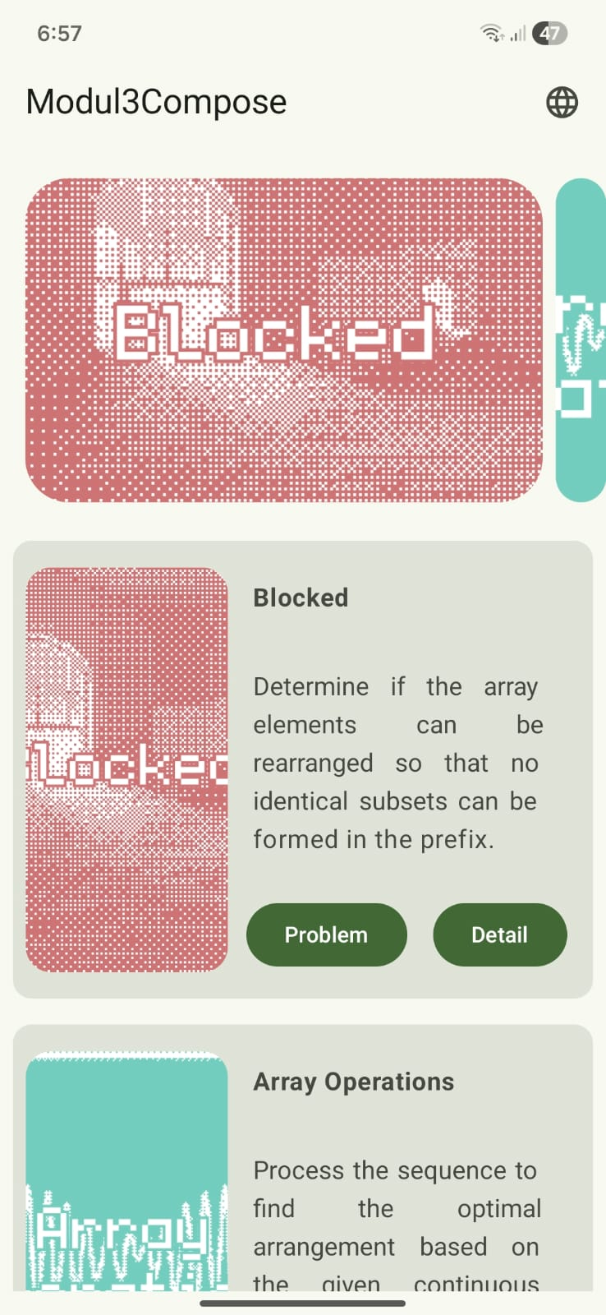Gambar 1. Home Page Compose English Modul 3
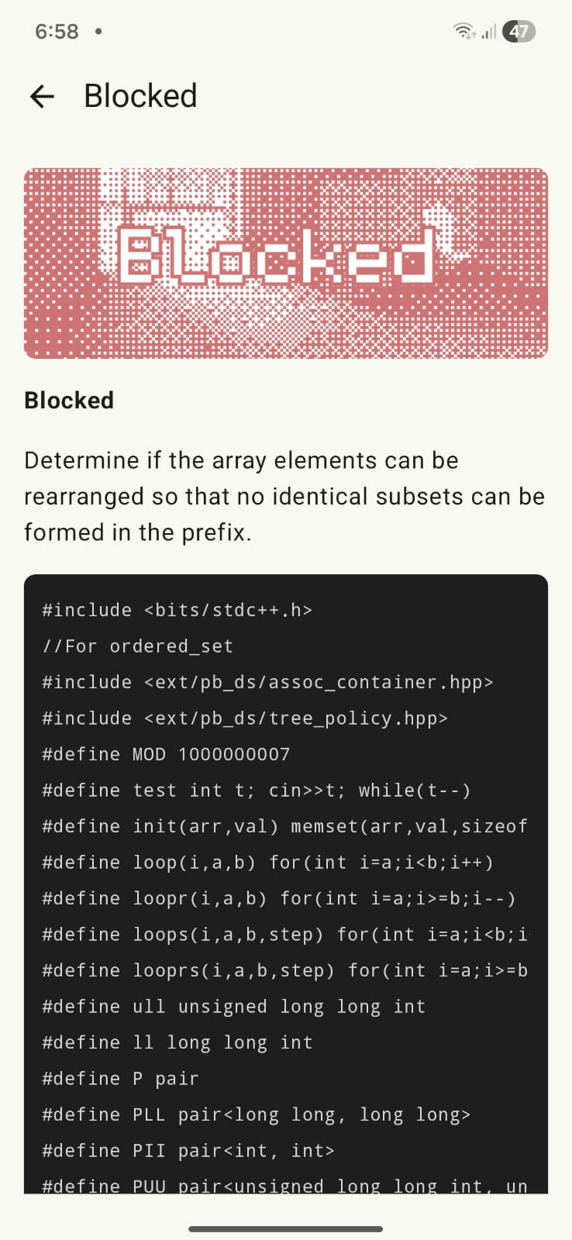Gambar 2. Detail Page Compose English Modul 3
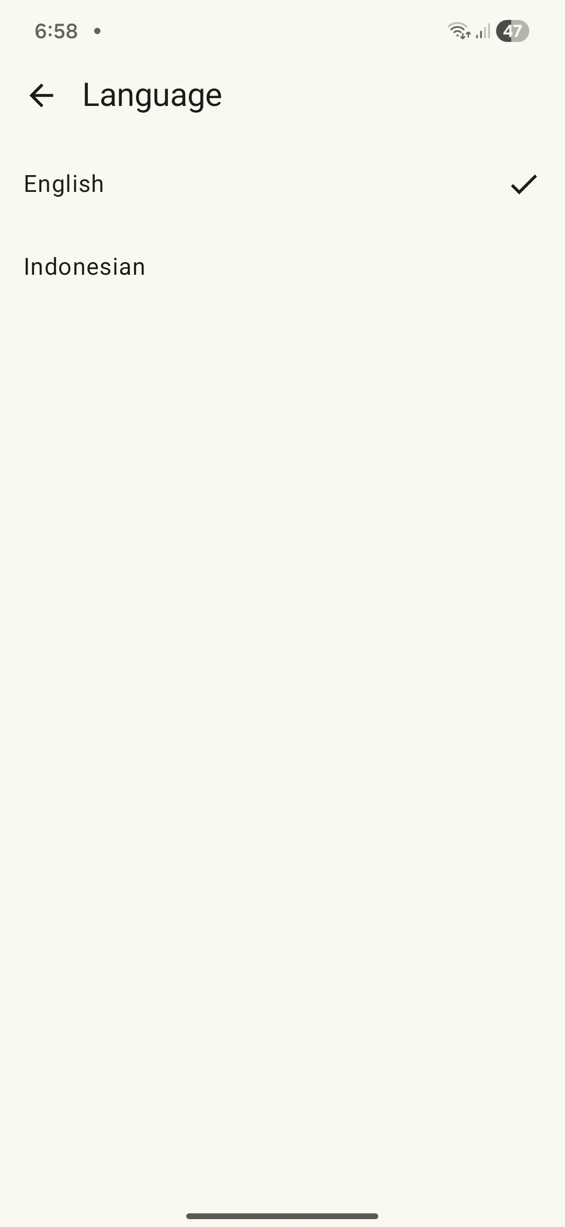Gambar 3. Language Page Compose English Modul 3
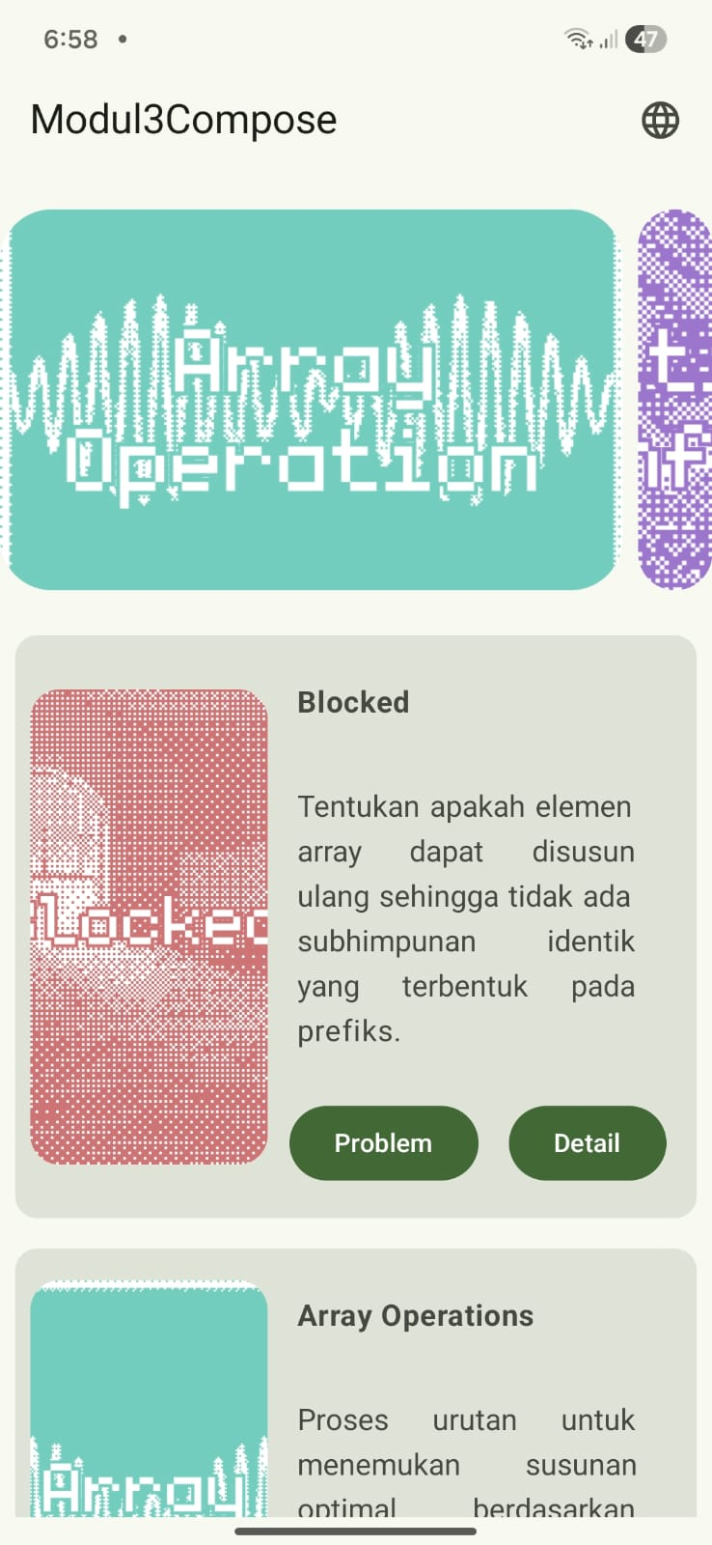Gambar 4. Home Page Compose Indonesia Modul 3
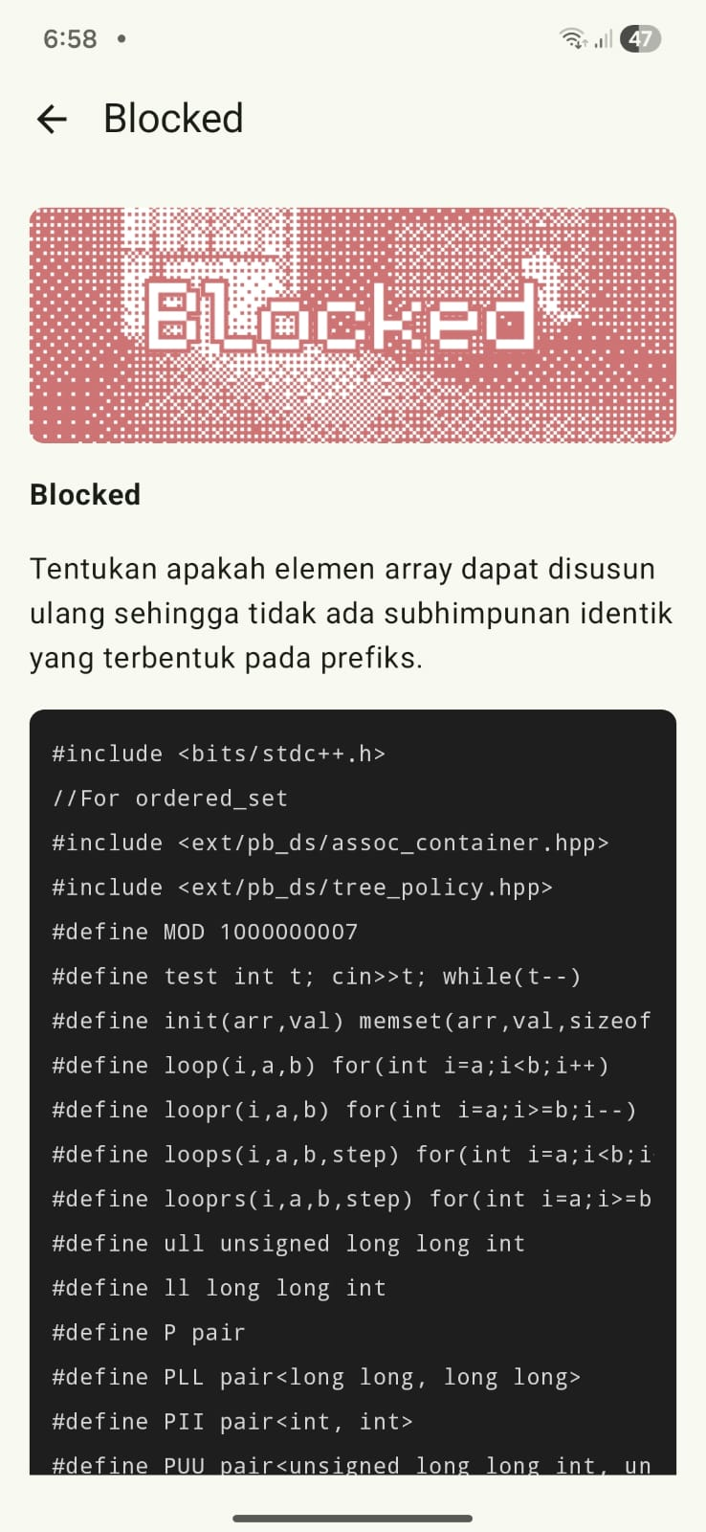Gambar 5. Detail Page Compose Indonesia Modul 3
XML
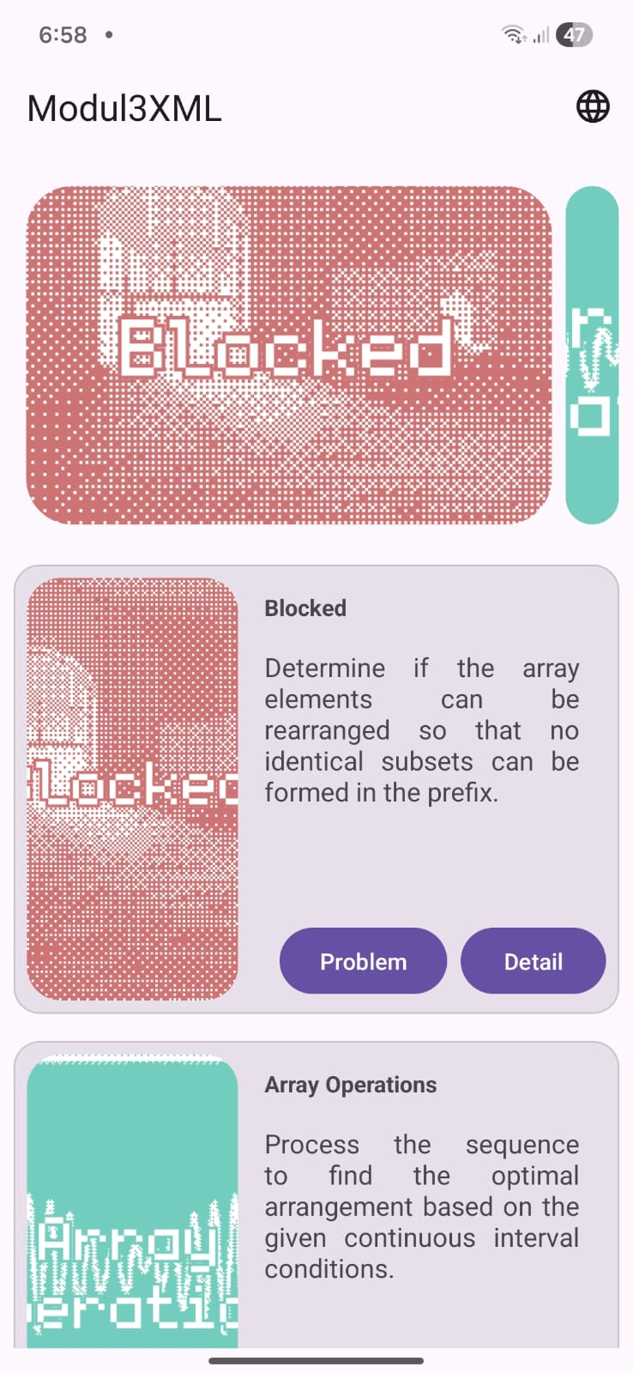Gambar 6. Home Page XML English Modul 3

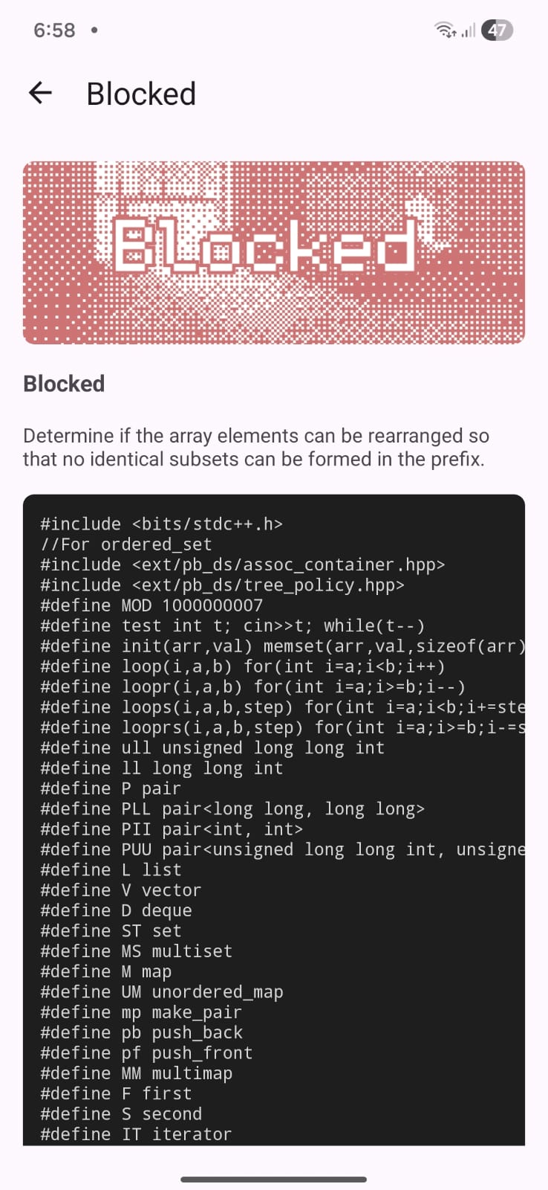Gambar 7. Detail Page XML English Modul 3
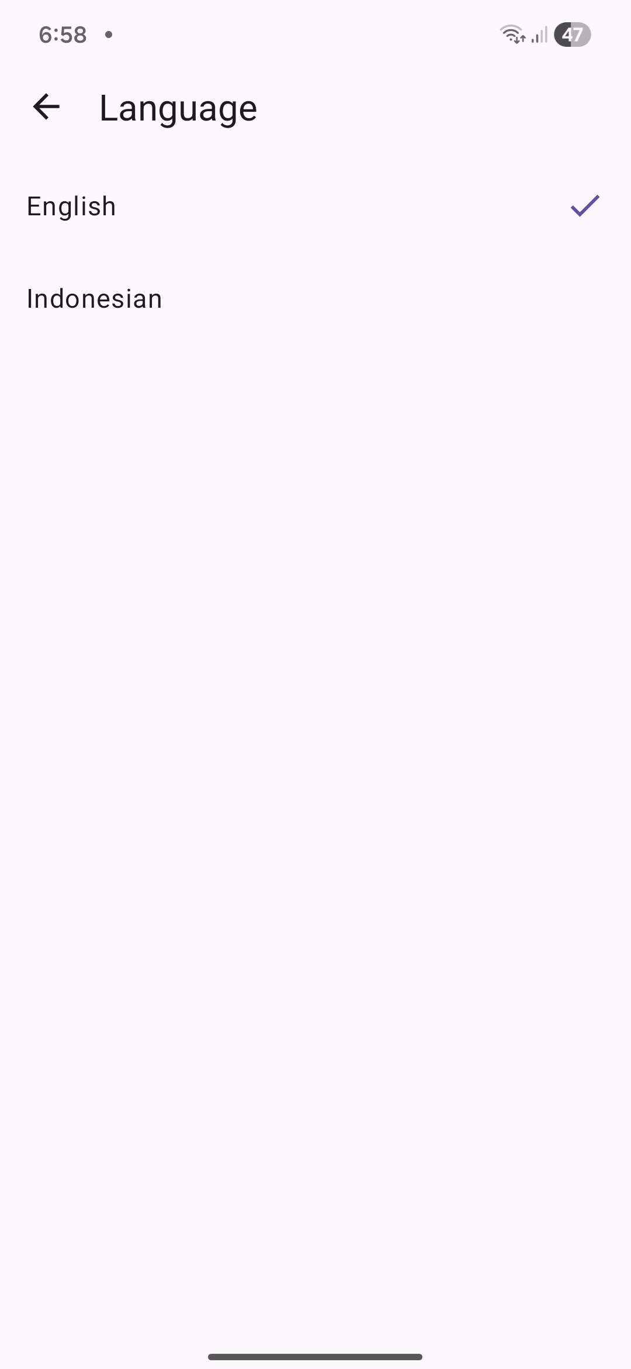Gambar 8. Langauge Page XML English Modul 3
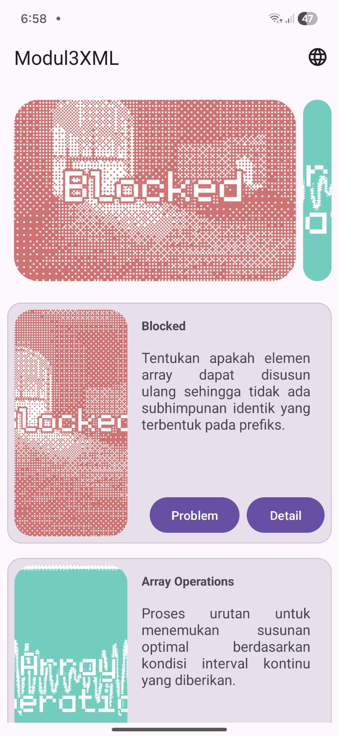Gambar 9. Home Page XML Indonesia Modul 3
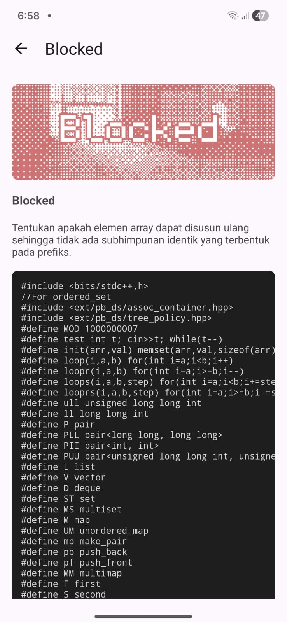Gambar 10. Detail Page XML Indonesia Modul 3

Pembahasan
Generic
Data
Saya menggunakan resource untuk menyimpan hampir semua data dari title, description dan image. Untuk solutionCode saya menggunakan raw (c++) supaya saya hanya perlu mengimport filenya saja tanpa diedit di dalam string.xml atau source code kotlin. Alasan kenapa saya menggunakan string resource untuk hampir semua data text adalah untuk mendukung fitur multi bahasa.

ViewModel
ViewModel (Home, Detail, Language) di Compose dan XML merupakan implementasi yang sama karena saya mendecouple-nya dari UI. Jadi, ketika saya migrasi dari Compose ke XML saya hanya perlu mengubah implementasi UI-nya saja.

Compose
MainActivity
MainActivity mewarisi AppCompatActivity bukan ComponentActivity karena dibutuhkan untuk mendukung AppCompatDelegate yang digunakan pada fitur multi bahasa. enableEdgeToEdge() dipanggil agar tampilan melebar hingga ke system bar. navController dibuat di sini menggunakan rememberNavController() lalu diteruskan ke AppNavigation, supaya lifecycle navigasi tetap terikat pada Activity. Hal ini membuat MainActivity menjadi entry point yang langsing no god class karena seluruh logika navigasi dan UI dipisahkan sepenuhnya ke Compose.

Home Screen
HomeScreen dipisah menjadi dua fungsi composable, yaitu HomeScreen yang menangani navigasi dan HomeContent yang menampilkan UI, saya pisah supaya responsibility antar komponen menjadi lebih pure. Daftar problem ditampilkan menggunakan LazyColumn untuk efisiensi rendering, dan dilengkapi HorizontalMultiBrowseCarousel di bagian atas sebagai navigasi visual dan karena diminta oleh laprak. Aksi membuka URL eksternal Codeforces ditangani langsung dengan Intent.ACTION_VIEW di dalam HomeContent menggunakan LocalContext, tanpa perlu meneruskan context ke ViewModel. Hal ini menjaga ViewModel tetap bebas dari depedency pada Android framework context.

Detail Screen
DetailScreen menggunakan LaunchedEffect(problemId) supaya update data hanya ketika problemId berubah, jadi tidak ada pemanggilan ulang yang tidak perlu saat rekomposisi. SolutionCode ditampilkan melalui composable CodePreview yang terpisah, dengan support horizontal scroll dan SelectionContainer agar pengguna bisa menyalin kode dengan mudah. Kondisi isNotFound dan titleRes == 0 digunakan sebagai indikator loading dan error state secara tidak explisit atau implisit tanpa memerlukan state tambahan. Pemisahan onBack sebagai lambda membuat DetailScreen tidak dependen pada NavController, sehingga lebih mudah diuji dan di-reuse.

Language Screen
LanguageScreen memisahkan antara lapisan navigasi dan lapisan UI dengan membagi composable menjadi LanguageScreen yang memegang NavController dan LanguageContent yang hanya menerima state dan callback. Setiap pilihan bahasa dirender menggunakan forEach karena jumlah bahasanya statis dan kecil, sehingga LazyColumn tidak diperlukan. Indikator bahasa yang sedang aktif ditampilkan dengan ikon centang melalui perbandingan currentTag == tag, memberikan feedback visual yang langsung dan jelas kepada pengguna. Pergantian bahasa ditangani sepenuhnya oleh LanguageViewModel menggunakan AppCompatDelegate, sehingga UI tidak perlu mengetahui mekanisme internal perubahan locale.

Navigation
AppNavigation menggunakan type-safe navigation dari Jetpack Navigation Compose dengan sealed class RoutingNames yang di-annotate dengan @Serializable, menghindari penggunaan string langsung yang rawan typo dan menghindari 2 jam debugging. Setiap composable di dalam NavHost langsung membuat instance ViewModel-nya masing-masing menggunakan viewModel(), sehingga lifecycle ViewModel selaras dengan back stack entry yang sesuai. Argumen navigasi untuk DetailScreen diekstrak menggunakan toRoute<>() yang memanfaatkan type-safety penuh tanpa perlu parsing manual dari Bundle. Pendekatan ini membuat graf navigasi menjadi satu-satunya tempat yang mengetahui hubungan antar screen, sementara masing-masing screen tetap independen satu sama lain.

XML
MainActivity
Pada XML enableEdgeToEdge() tetap digunakan dan padding system bar ditangani secara manual melalui ViewCompat.setOnApplyWindowInsetsListener, sehingga konten tidak tertutup oleh status bar maupun navigation bar. Penggunaan ViewBinding memastikan akses ke view dilakukan secara type-safe tanpa findViewById. Dengan pola ini, MainActivity pure bertugas sebagai container navigasi tanpa menyimpan logika bisnis apapun.

Home Fragment
HomeFragment menggunakan dua RecyclerView terpisah, yaitu satu untuk carousel dengan CarouselLayoutManager + HeroCarouselStrategy dan satu untuk list problem dengan LinearLayoutManager, keduanya di-submit data yang sama dari ViewModel secara bersamaan. Kedua adapter yaitu CarouselAdapter dan ProblemListAdapter mewarisi ListAdapter yang memanfaatkan DiffCallback, sehingga update list dilakukan secara efisien dengan animasi diff otomatis tanpa perlu notifyDataSetChanged(). Observer state menggunakan repeatOnLifecycle(STARTED) untuk memastikan collection Flow hanya aktif saat Fragment benar-benar terlihat, menghindari pemborosan resource yang banyak di background. Navigasi ke DetailFragment diimplementasikan dalam satu fungsi navigateToDetail() agar mengikuti konsep DRY untuk navigasi dari problem carousel dan dari problem card.

Detail Fragment
DetailFragment mengambil problemId dari arguments yang dikirim melalui Bundle saat navigasi, lalu langsung memanggil viewModel.loadDetail() di onViewCreated sehingga data mulai di-fetch begitu view siap. Tampilan konten dan pesan “not found” dikontrol dengan mengubah visibility secara eksplisit atau tidak implisit berdasarkan state dari ViewModel, pola yang setara dengan kondisi isNotFound dan titleRes == 0 di versi Compose. SolutionCode ditampilkan di dalam HorizontalScrollView yang memiliki anak (child) TextView dengan textIsSelectable="true", memberikan anaknya ability untuk scroll horizontal dan text selection yang fungsionalitasnya sama persis dengan CodePreview di versi Compose. Binding di-null-kan di onDestroyView() untuk mencegah memory leak yang umum terjadi pada Fragment dengan ViewBinding.

Language Fragment
LanguageFragment menggunakan RecyclerView dengan LanguageAdapter alih-alih forEach seperti di versi Compose, karena RecyclerView lebih sesuai dengan paradigma XML dan tetap efisien untuk daftar yang mungkin bertambah di masa depan. Status bahasa yang dipilih direpresentasikan melalui field isSelected di LanguageModel yang dihasilkan dari mapping di observer, sehingga LanguageAdapter tidak perlu mengetahui selectedTag secara langsung dan tugasnya pure untuk menampilkan data. Perubahan bahasa tetap ditangani oleh LanguageViewModel menggunakan AppCompatDelegate, konsisten dengan versi Compose, sehingga Fragment tidak terlibat dalam logika pergantian locale sama sekali. Pola setup yang dipisahkan menjadi setupToolbar(), setupRecyclerView(), dan observeViewModel() membuat onViewCreated tetap clean dan mudah dibaca oleh anak berusia 5 tahun.

Nav Graph
nav_graph.xml mendefinisikan seluruh struktur navigasi aplikasi dalam satu file XML, setara dengan peran AppNavigation.kt di versi Compose. Argumen problemId untuk DetailFragment dideklarasikan langsung di dalam tag <fragment> dengan app:argType="string", sehingga janji manis atau contract antar destination terdokumentasi di satu tempat yang terpusat. Navigasi antar fragment dilakukan menggunakan action ID seperti R.id.action_homeFragment_to_detailFragment, yang meskipun tidak se-type-safe toRoute<>() di Compose, tetap terstruktur dan tidak tersebar di berbagai tempat karena semua navigasi dikelola dari fragment asal masing-masing. Pendekatan ini memungkinkan Android Studio untuk memvisualisasikan graf navigasi secara visual, yang memudahkan pemahaman alur aplikasi bahkan untuk orang bisnis sekalipun.

SOAL 2
Mengapa RecyclerView masih digunakan, padahal RecyclerView memiliki kode yang panjang dan bersifat boiler-plate, dibandingkan LazyColumn dengan kode yang lebih singkat?

Pembahasan
RecyclerView masih banyak digunakan karena di XML memang tidak ada alternatif lain yang setara dengan LazyColumn, berbeda dengan Compose yang menyediakan LazyColumn dengan paradigma deklaratif dan tanpa boilerplate seperti Adapter maupun DiffCallback. Jika konteksnya adalah pengembangan berbasis Compose, LazyColumn jelas menjadi pilihan utama saya karena kodenya lebih ringkas dan lebih menyenangkan untuk dikoding, ketika saya ngoding pakai Compose saya mendapatkan dopamin yang tinggi dan low cortisol.
Namun XML sendiri masih banyak digunakan di industri karena migrasi ke Compose tidak selalu worth it, terutama pada proyek yang sudah berjalan lama dan terlalu besar. Biaya migrasi dari sisi waktu dan resiko performa melambat sering kali dianggap lebih besar daripada manfaat yang didapat, sehingga kata orang bisnis keputusan untuk tetap bertahan di XML masih sangat masuk akal.

SOAL 3
Pada desain arsitektur kotlin, terdapat beberapa arsitektur dengan salah satunya adalah CLEAN ARCHITECTURE, menurut pendapat kalian, mengapa kita harus menerapkan arsitektur ini ketika membuat sebuah project?

Pembahasan
Menurut saya Clean Architecture harus diterapkan karena memisahkan logika bisnis dari UI, sehingga setiap modul memiliki responsibility yang jelas dan perubahan di satu sisi tidak merembet ke sisi lain. Bukti nyatanya dapat terlihat di proyek ini, di mana ViewModel yang sama berhasil digunakan di dua versi UI dengan paradigma yang berbeda yaitu Compose dan XML, tanpa perubahan apapun pada logika bisnisnya. Selain manfaat teknisnya, kode yang terstruktur rapi juga mengurangi beban kognitif developer sehingga menghasilkan developer yang low cortisol dan high dopamin, alhasil meningkatkan produktivitas dan pada akhirnya memberikan dampak positif terhadap kualitas produk secara keseluruhan.

LINK GITHUB
https://github.com/Gunturadhtya/Praktikum-Pemrograman-Mobile

